**TOPICS: Allowed Time:** 60 Minutes

**Instructions: Total Marks:** 15 **(10 Solid Marks)**

1. Gossips are not allowed.
2. Teacher assistants are for your help, so be nice with them. Respect them as they are teaching you. Raise your hands if you have some problem and need help from TA. Avoid calling them by raising your voice and disturbing the environment of Lab.
3. TA may deduct your marks for any kind of ill-discipline or misconduct from your side.
4. Evaluation will be considered final and you cannot debate for the marks. So, focus on performing the tasks when the time is given to you.
5. Paste the query as well as result table screenshot as a result of each task

**Task 01: _________________________ ___________ (05 Marks)**

1. Find employees who earn a salary between **1200** and **3000** (inclusive) and have a commission greater than **500** or no commission at all.

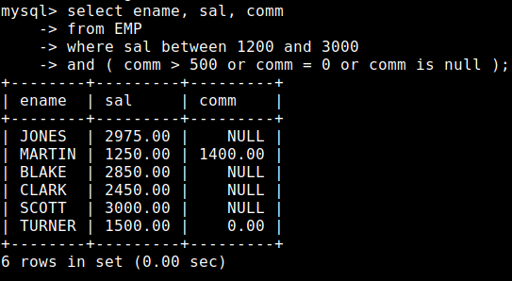

1. List Employees Who Have Never Managed Anyone.

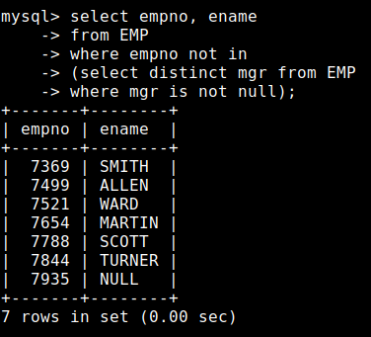

1. Find department names that have more than **2** employees.

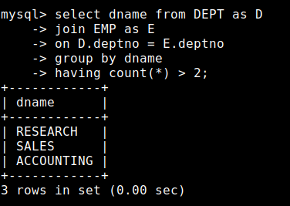

1. Display the employee name in uppercase, the first **3** letters of their job title, and the length of their name.

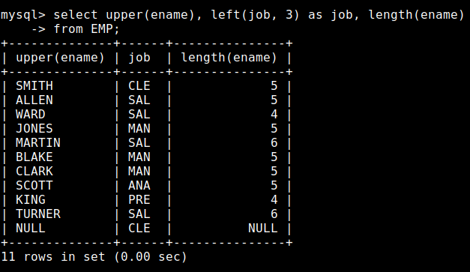

1. Find the department with the highest total salary and also print Total salary with dept no.

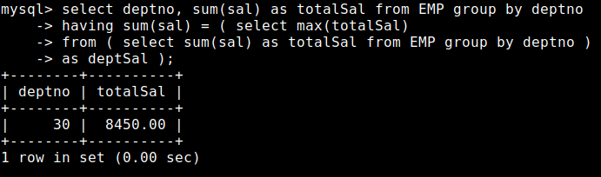

**Task 02: _________________________ ___________ (10 Marks)**

1. List employees with their department name, location, salary grade, and indicate with (Above Average and Below Average ) if their salary is above the average salary of their department.

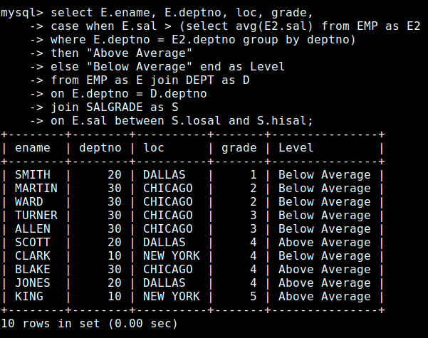

1. List all employees who earn a salary above the average salary of their department, along with their department name, total employees in the department, and the percentage of department salary a listed employee contribute.

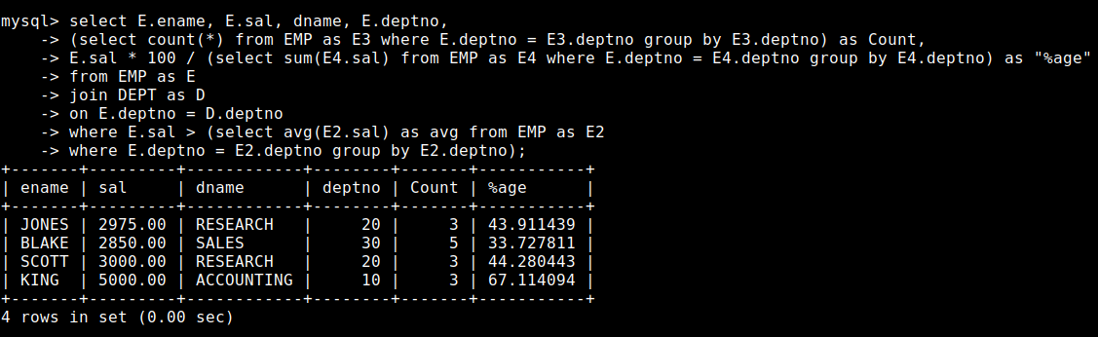

1. Find employees whose salaries are higher than all the managers in their department, along with their department name.

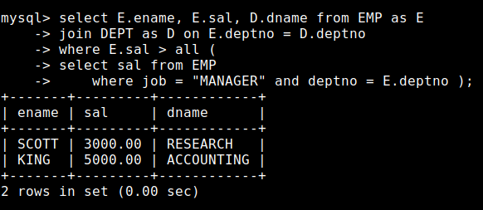

1. Display employees whose commission (if any) is more than **10%** of the total salary of their department. Include their name, department name, commission, and total department salary.

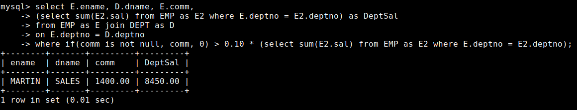

1. Find the department with the highest total number of employees who were hired after 1981. Display the department name and the total count.

